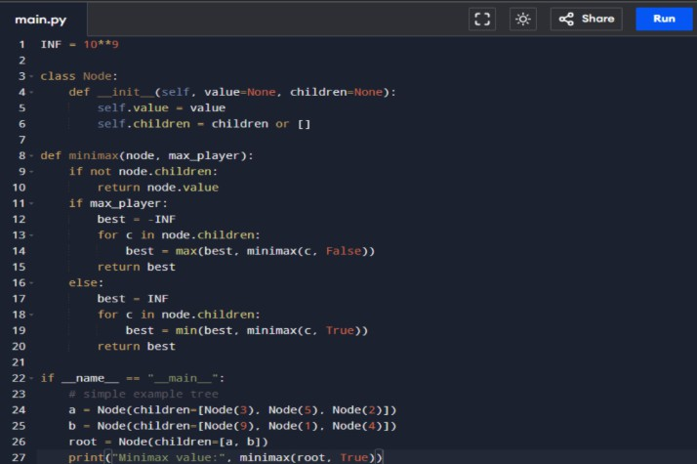

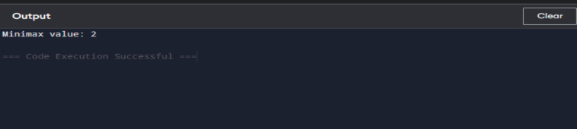

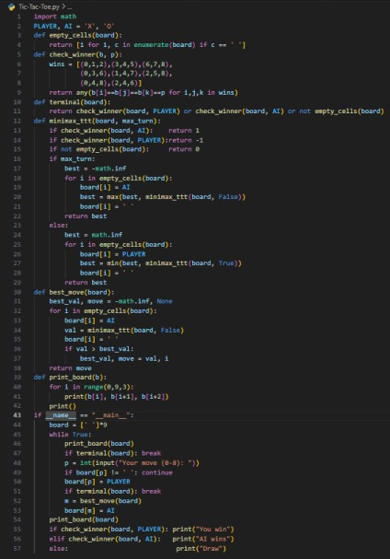

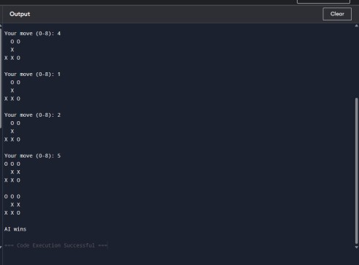

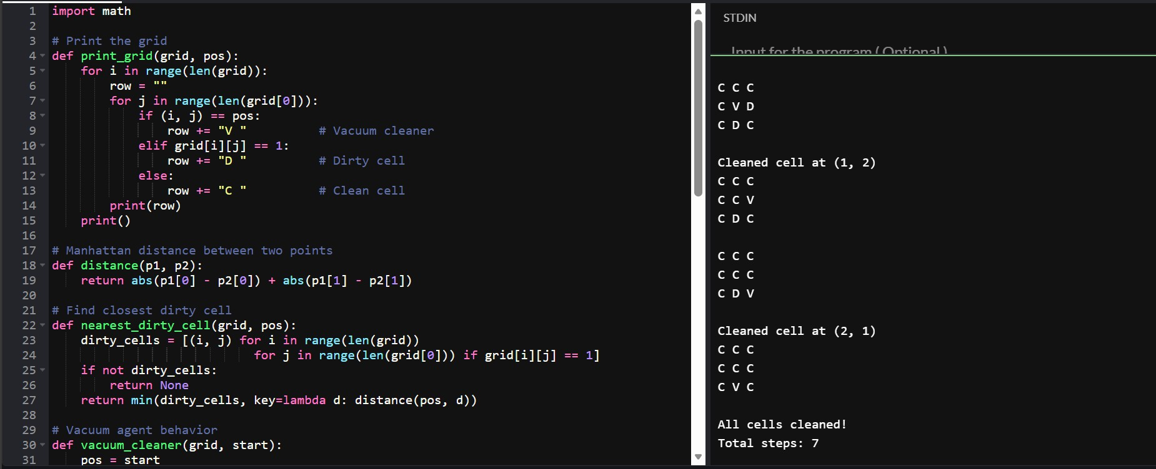

1. N QUEENS
import random

# ---- Cost Function: Count attacking pairs ---- def cost(state):
n = len(state) attacks = 0

for i in range(n):
for j in range(i + 1, n): # Same row
if state[i] == state[j]: attacks += 1
# Same diagonal
if abs(state[i] - state[j]) == abs(i - j): attacks += 1
return attacks

# ---- Generate all neighbors ---- def get_neighbors(state):
neighbors = [] n = len(state)

for col in range(n): for row in range(n):
if row != state[col]: new_state = state.copy() new_state[col] = row
neighbors.append(new_state) return neighbors

# ---- Hill Climbing Algorithm ---- def hill_climb(n):
# Start with a random state
current = [random.randint(0, n - 1) for _ in range(n)] current_cost = cost(current)

while True:
neighbors = get_neighbors(current) best = current
best_cost = current_cost

for n_state in neighbors: c = cost(n_state)
if c < best_cost: best = n_state best_cost = c

# If no improvement → Stop if best_cost >= current_cost:
return current, current_cost

# Otherwise move to better state current = best
current_cost = best_cost

# ---- Random Restart Version ----
def hill_climb_with_restart(n, max_restarts=50): for _ in range(max_restarts):
solution, c = hill_climb(n) if c == 0:
return solution, 0
return solution, c # Best found

# ---- Print board ---- def print_board(state):
n = len(state) for r in range(n):
row = ""
for c in range(n): if state[c] == r: row += " Q "
else:
row += " . " print(row)

# ---- Run for N = 8 ----
n = 8
sol, final_cost = hill_climb_with_restart(n)

print("Final State:", sol) print("Final Cost:", final_cost)
print("Valid Solution Found:", final_cost == 0) print("\nBoard:")

print_board(sol)

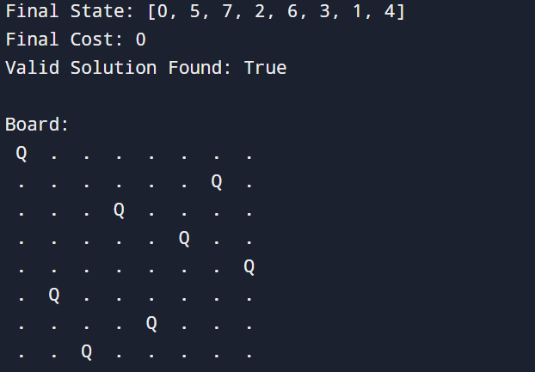

2 MIN MAX
def minimax(node, depth, is_maximizing, values): # If leaf node
if depth == 2:
return values[node]

if is_maximizing: return max(
minimax(node*2, depth+1, False, values), minimax(node*2+1, depth+1, False, values)
)
else:

return min(
minimax(node*2, depth+1, True, values), minimax(node*2+1, depth+1, True, values)
)

# Leaf values: index position: 0 1 2 3
values = [3, 5, 2, 9]

result = minimax(0, 0, True, values) print("Best value for MAX player:", result)

if result == 3:
print("MAX should move: LEFT (L)") else:
print("MAX should move: RIGHT (R)")

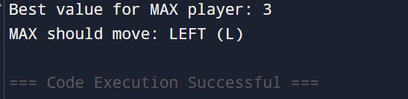

3.A*SEARCH
import heapq

# Graph representation graph = {
'A': {'B': 1, 'C': 4},
'B': {'D': 3, 'E': 5},
'C': {'F': 2},
'D': {'F': 1, 'E': 1},
'E': {'F': 2}, 'F': {}
}

# Heuristic values (straight-line distance to goal F) h = {
'A': 4,
'B': 3,
'C': 2,
'D': 1,
'E': 2,
'F': 0
}

def a_star(start, goal): pq = []
heapq.heappush(pq, (h[start], start)) # priority queue

g = {node: float('inf') for node in graph} g[start] = 0

parent = {start: None} visited_order = []

while pq:
f_val, node = heapq.heappop(pq) visited_order.append(node)

if node == goal: break

for neighbor, cost in graph[node].items(): new_g = g[node] + cost
if new_g < g[neighbor]: g[neighbor] = new_g
f_val = new_g + h[neighbor] parent[neighbor] = node heapq.heappush(pq, (f_val, neighbor))

# Reconstruct path path = []

cur = goal
while cur is not None: path.append(cur) cur = parent[cur]
path.reverse()

return visited_order, path, g[goal]

# ---- Run A* ----
visited, path, total_cost = a_star('A', 'F')

print("Order of Node Expansion:", visited) print("Optimal Path:", " → ".join(path)) print("Total Cost:", total_cost)

